COMPUTER ARCHITECTURE & SYSTEMS LAB

Day 2 Assignment: Motherboard & CPU Architecture
Topic: ATX Form Factors, Socket Mechanics, Chipset Interconnects, and Practical Identification
TASK 1: TECHNICAL LAYOUT
1. Labeled Structural Diagram of an ATX Motherboard
Below is a highly accurate schematic architectural layout of a standard ATX form-factor motherboard, mapping out critical logic tracks, sockets, expansion interfaces, and peripheral buses.
1. CPU Socket (LGA/PGA)
2. DDR DIMM Slots
nel Shield
CPU SOCKET
3. 24-Pin ATX Power
DIMM RAM SLOTS
nsion Slot
PCIe 4.0/5.0 x16 SLOT
CHIPSET
4. SATA III Connectors
5. Platform Controller Hub (Chipset)
6. Internal USB Headers

TASK 2: MARKET ANALYSIS
2. CPU Socket Evolution and Compatibility
CPU sockets form the physical, electrical, and mechanical interface between the processor and the motherboard. Sockets determine generational compatibility and pin alignment architectures.
Note: The transition of AMD from AM4 (PGA) to AM5 (LGA) highlights an industry-wide trend toward
Land Grid Array interfaces, which offer increased pin density and structurally safer chip handling.

LGA 1700 | Intel | Land Grid Array (1700 pins) | Intel Core i7-13700K (Raptor Lake)
AM5 (LGA 1718) | AMD | Land Grid Array (1718 pins) | AMD Ryzen 7 7800X3D (Zen 4)
Socket Type | Manufacturer | Architecture Class | Compatible CPU Model Example
AM4 | AMD | Pin Grid Array (1331 pins) | AMD Ryzen 5 5600X (Zen 3)

TASK 3: THEORETICAL SYSTEM MECHANICS

3. Primary Functions of CPU and Chipset

The Central Processing Unit (CPU)
The CPU is the primary computational engine of the computer system. It continuously executes instructions structured via the Fetch-Decode-Execute cycle. Its internal Core execution units process mathematical operations (via the ALU) and manage data routing (via the Control Unit), interacting deeply with multi-tiered on-die cache lines (L1, L2, L3) to keep data latency to an absolute minimum.

The Chipset
The chipset (historically structured as Northbridge/Southbridge, now unified into platforms like Intel Z790 or AMD X670) acts as the data communications backbone and switchboard of the motherboard. It manages data transfers between the CPU and slower peripheral interfaces such as SATA controllers, USB ports, onboard audio, Wi-Fi modules, and secondary PCIe expansion lines.

System Coordination: Launching a Music App (e.g., Spotify)
When an end-user triggers the Spotify application, the CPU and Chipset execute a synchronized choreography across the structural buses:
- Storage Fetch: The CPU receives the execution instruction and routes a data command through the chipset down to the storage subsystem (e.g., an NVMe M.2 SSD or SATA SSD). The chipset manages the peripheral bus protocol to retrieve the core application binaries into system RAM.
- Instruction Decoding & Processing: As the binaries load, the CPU executes the initialization code, builds the Graphical User Interface (GUI) elements, and manages network requests via the network controller (connected through the chipset lines) to retrieve user data and audio streams from remote servers.
- Audio Pipeline Routing: When an audio stream plays, the CPU decodes the compressed digital audio files (e.g., Ogg Vorbis format). It then forwards the digital stream down the high-speed interconnect lines to the chipset, which handles timing and distribution to the integrated high-definition audio controller or an external USB DAC, transforming digital bits into audible acoustic waveforms.

TASK 4: PRACTICAL LAB COMPONENT

4. Real Motherboard Port Identification Exercise

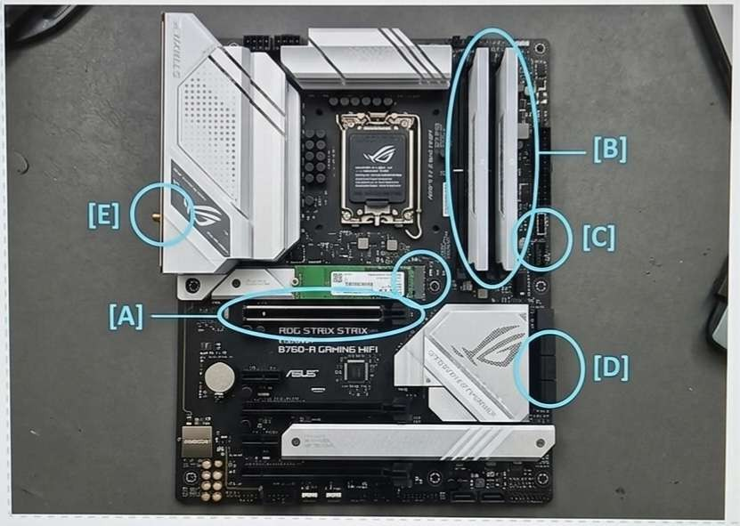
Instructions: Use your local physical machine or source a high-resolution photograph of a modern motherboard. Map, highlight, and circle five unique ports or slots, logging their detailed operational parameters below.

[Student Lab Documentation Area]
Affix or sketch your verified motherboard photograph here.
Circle and label 5 distinct items corresponding to the data registry table below.

ID Mark Identified Port / Slot Name Observed Hardware Standard / Functionality
[ A ] | e.g., PCIe x16 Slot | Primary high-speed graphics slot running at PCIe Gen 4.0 speeds.
[ B ] | e.g., M.2 NVMe Slot | Solid-state storage interface using 4 dedicated PCIe lanes.
[ C ] | e.g., HDMI Port | Rear I/O digital video output driven by CPU integrated graphics.
[ D ] | e.g., USB 3.2 Gen 2 Type-A | High-speed external peripheral data port on the rear I/O shield.
[ E ] | e.g., 8-Pin CPU Power Connector | Provides direct +12V electrical current to the CPU Voltage Regulator Modules.

